Name:
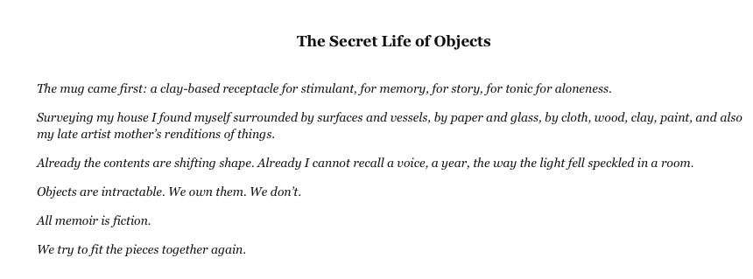
Date:
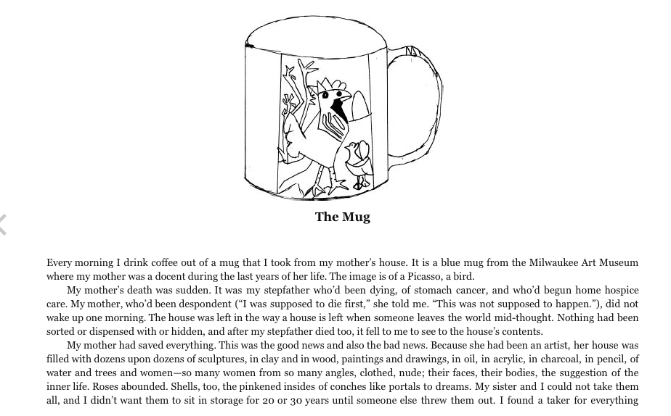
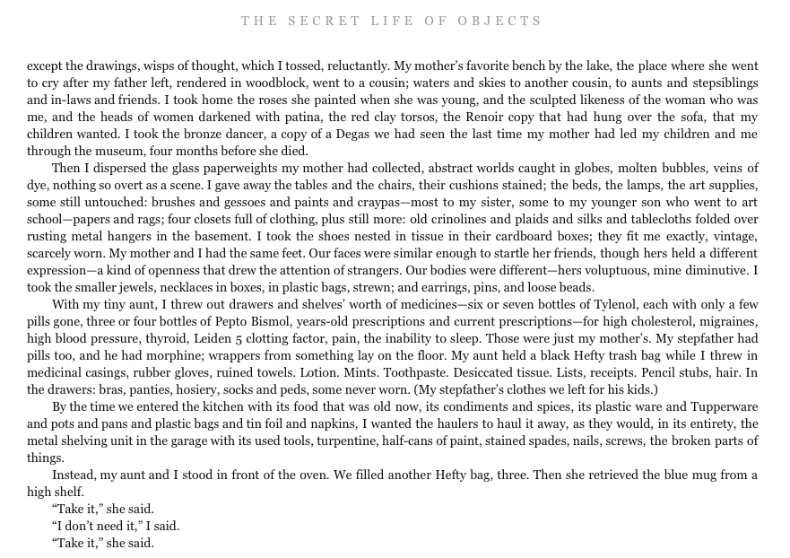
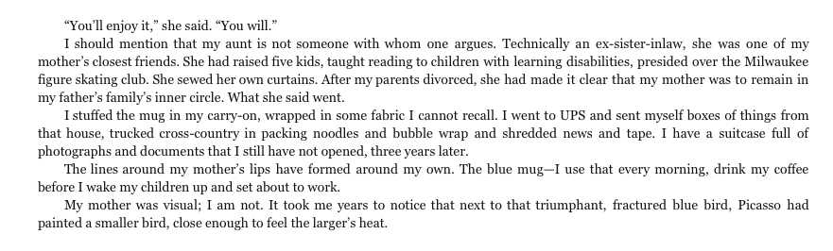

Self-Practice: Your Object

1. Discovery
- When and how did you first receive or encounter the object?
- What was your first impression of it?
- Who was there?

2. Meaning
- Did you know it was significant from the beginning?
- How did your object gain meaning?
- Has its meaning changed over time?

3. Value
- What does the object say about you?
- What event or person taught you the importance of this object?
- What if you lost it?
- Is there a time when you really need it?

4. Reward
- What is the best reward of owning your object?

5. Conclusion
- If you had to give it to someone, who would that be and what would you say to them?
6. Description
- What does it look like?
- What does it feel like?
- What does it smell like?
- Where is it right now?

