Name:
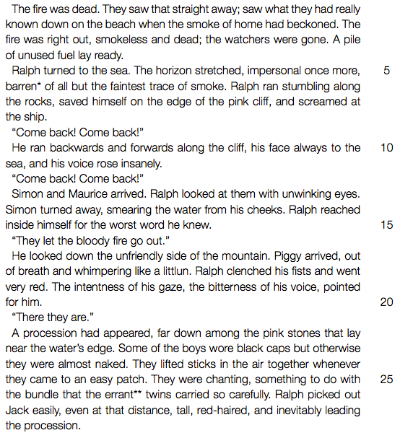
Date:

1. Refer to line 2: “the smoke of home had beckoned.”
(a) What is being referred to in these words? (b) Explain why the smoke is described as “the smoke of home”.
2. Refer to lines lines 9-10: “his voice rose insanely. ‘Come back! Come back!’ ” What is Ralph feeling at this point in the novel? Explain why he feels this way.
3. Choose the correct answer from the choices given below. “Ralph clenched his fist and went very red.” (Lines 16-17) This shows us that Ralph:
A) is embarrassed because Simon is crying.
B) is angry with Jack and the hunters for allowing the fire to go out.
C) is upset because the ship passed them by.
D) is very sunburnt.
4. Why do the boys paint their faces before the pig hunt? State TWO
reasons.
5. Give two reasons why, in your opinion, the event described in this extract makes Ralph feel closer to Piggy.

