Name:
Date:

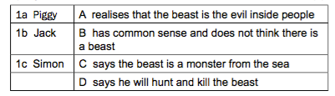
1. Match the names in COLUMN 1 to the descriptions in COLUMN 2.

2. Is the following statement TRUE or FALSE? Write “true” or “false” and give a reason for your answer.
“Ralph did not want to go on being chief because he was tired of the responsibility.”
3. Explain why Piggy says if they had no fire they would stay on the island until they died.
4. Why do you think Jack hates Piggy? Give TWO reasons for your opinion.
5. In your OWN WORDS explain the reasons Piggy gives for saying that Jack hates Ralph.
6. “ ‘I had the conch,’ said Piggy simply. ‘I had a right to speak.’ “ (Line 14) What theme is referred to in these words? Give a reason for your answer.
7. Before this extract, earlier in Chapter 5, the boys had a meeting. Why did Ralph call the meeting? After the meeting has broken up, why does Ralph refuse to blow the conch to call the boys back?

