Name:
Date:

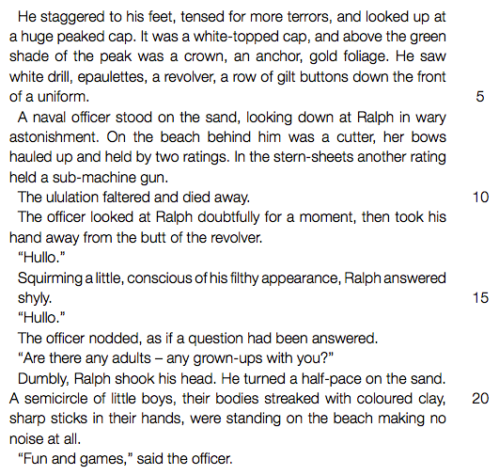

1. Is the following statement TRUE or FALSE? Using your own words, give a reason for your answer.
“The naval officer is on the island because he saw the signal fire.”
2. The officer thinks the boys are playing a game.
Briefly describe what is actually happening on the island when the officer arrives. State TWO points.
3. Refer to lines 2-4 (“It was a ... of a uniform”).
The writer describes the officer’s uniform in great detail.
How does the appearance of the officer differ from that of the boys?
4. Refer to the words “wary astonishment” in lines 5-6.
Using your own words, explain what these two words show about the officer’s feelings about Ralph. State TWO things.
5. Choose the correct answer to complete the following sentence: In line 6 the word “cutter” means...
A boat
B helicopter
C tank
D ship

6. Refer to lines 10-16 (“The officer looked... had been answered”).
(a) Quote ONE word from the extract to show that Ralph is feeling uncomfortable. (b) Explain why it is so important to the officer to have the “question” in his mind answered.
. State TWO points.
. Just before the events in the extract Ralph thinks of the boys as “savages”. Why does he now see them as “little boys”?
. The officer is disappointed because the boys cannot tell him how many of them there are. Why does he expect them to be more organized?
. The games on the island often get out of control.
Do you think the boys’ violent behavior can be excused? Explain your answer.
. Consider the novel as a whole.
Do you think evil wins in the end? Discuss your view.
. What does the novel as a whole convey about Ralph’s character?
. Is the following statement TRUE or FALSE? Sam ‘n Eric remain loyal
to Jack throughout the novel. Give a reason for your answer.

