Name:
Date:
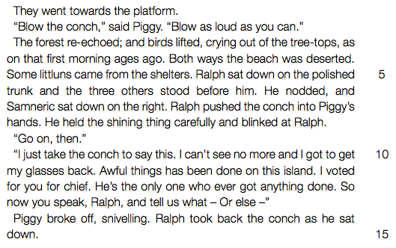

- Refer to line 2 (“Blow the conch... as you can”).
(a) Briefly describe the events that lead to the conch being blown at this point in the novel. (b) Why is the blowing of the conch so important to Piggy? State TWO points.
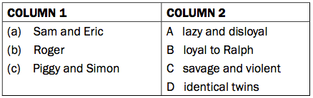
- Match the names in COLUMN 1 to the descriptions in COLUMN 2.

- Refer to lines 6-7 (“Ralph pushed the conch into Piggy’s hands”).
(a) What does the word “pushed” show about Ralph’s feelings? (b) Explain why Ralph feels this way.
- Refer to line 11 (“Awful things has been done on this island”). What does this sentence suggest about the behavior of some of the boys. State TWO points.
- Refer to lines 12-13 (“So now you speak, Ralph, and tell us what – Or else – ” ). (a) Why is Piggy’s sentence incomplete? (b) What do you think Piggy was going to say before he suddenly stopped?Complete the sentence he begins: “Or else … (c) Do you agree with Piggy that it was time for Ralph to take a stand and speak up? Explain your answer.
- Do you think Piggy is right to criticize Ralph’s leadership? Discuss your view.

