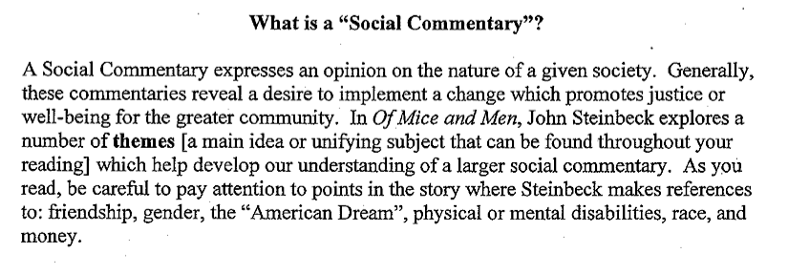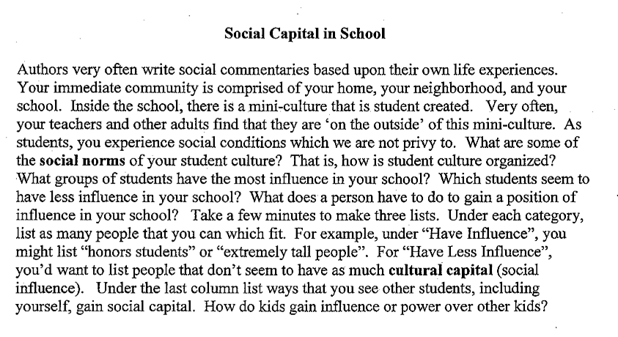

People or Groups with More Power | People or Groups with Less Power | Things Students do to Gain Power

Are there any themes that connect to these people or groups?
____________________________________________________________________________
____________________________________________________________________________ ____________________________________________________________________________

Look at the social divisions in our school. What works? What is unfair and needs to be changed? What could be done to improve these conditions?

____________________________________________________________________________
____________________________________________________________________________
____________________________________________________________________________
____________________________________________________________________________
____________________________________________________________________________
____________________________________________________________________________
____________________________________________________________________________
____________________________________________________________________________ ____________________________________________________________________________ ____________________________________________________________________________ ____________________________________________________________________________ ____________________________________________________________________________ ____________________________________________________________________________

