Name:
Date:

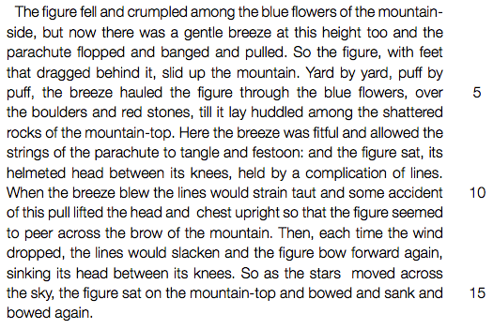
Chapter 6

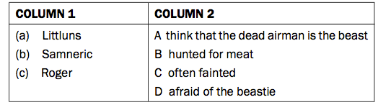
1. Match the names in COLUMN 1 to the descriptions in COLUMN 2.

2. (a) To what does “the figure” in the extract refer? (b) How does the figure end up on the island? State TWO points. (c) Who discovers the figure on the mountain top later?
3. Refer to line 6 (“Here the breeze was fitful...”).
(a) Why does the writer describe the breeze in this way?
(b) What does the breeze do to the figure?
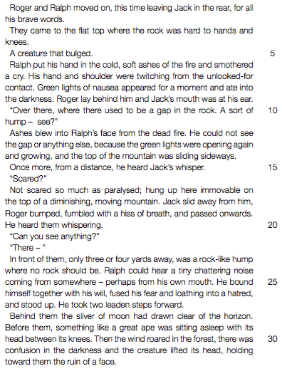
4. The figure lands close to where the fire normally is.
(a) How does this affect the boys’ plans? State THREE things.
(b) How do Jack and Ralph differ in their views of the importance of the fire?
Chapter 7

1. Use the words in the box below to complete the following sentences. Write down only the letter given in the space and beside it write the correct word.
Ralph felt very .............(a) when he wounded a ..........(b) . He then joined in the game of “Kill the pig” and hit ..........(c) with a spear and wanted to .......... (d) him.

2. Choose the correct word to complete the sentence below. Write down only the number of the question and beside it the letter of the correct answer.
The person who runs back to tell Piggy that the boys are going to climb up the mountain is ...
(a) Sam
(b) Simon
(c) Robert
3. Refer to line 1. Why did Jack walk behind Ralph and Roger in spite of “all his brave words”?
4. What was the tragic result of the earlier fire that had left ashes on the mountain?
5. Refer to lines 15-16. What figure of speech is used in the words “a hiss of breath”? Choose the correct answer and write only the letter (A-D) next to the question number.
A simile B personification C onomatopoeia D alliteration

6. Refer to line 22. (“He took two leaden steps forward.”)
(a) Name the figure of speech used in this line. (b) Explain how this figure of speech helps us to understand the way Ralph is moving.

7. “Before them, something like a great ape was sitting asleep with its head between its knees.” (lines 23-24)
(a) To what do the words “something like a great ape” refer? (b) Explain why it “lifted its head” when the wind blew.
8. How does Ralph show a new feeling of friendship for Simon and why does he feel this way?
9. What is surprising about Ralph’s behavior during the “Kill the pig” dance?

10. Why is Simon not afraid to go alone in the growing dark to tell Piggy what has happened?

