Name:
Date:
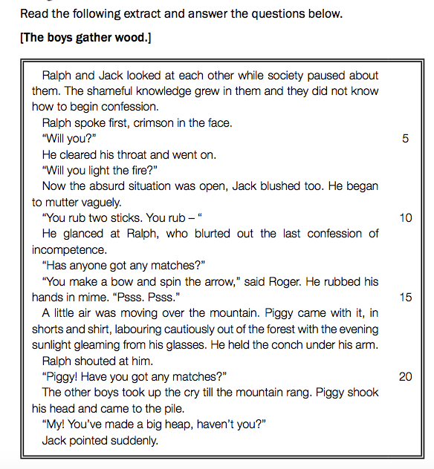
Lord of the Flies Chapter Two Questions

1. Complete the following sentences by using the words provided in the list below. Write only the words next to the question number (1(a)- 1(d)).
The (a) ... boys gather wood to light a (b) ... fire to attract passing (c)
... with its (d) ...
2. To whom does “society” in line 1 refer?
3. Refer to lines 1-3: “The shameful knowledge ... to begin confession.”
Give TWO reasons why this knowledge is so “shameful”.
4. In line 4 the writer mentions that Ralph turns “crimson in the face”.
Which emotion causes Ralph to turn crimson?
5. In line 14, “Psss. Psss.” is an example of...
A apostrophe
B onomatopoeia
C assonance
D oxymoron
6. Give TWO of Piggy’s characteristics that we learn from the words “labouring cautiously” in line 16.
7. Give TWO reasons why all the boys “took up the cry” (line 20).
8. In your opinion, should starting a fire on the island have been the most important concern? Discuss your view.

9. Update the character chart with evidence from chapter two (cite page numbers).

