Name:
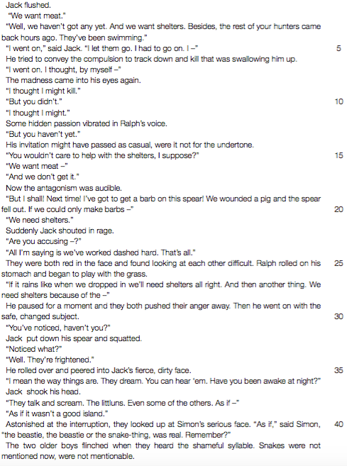
Date:

1. Why does Ralph complain about the fact that Jack’s hunters “came back hours ago” and have been swimming? (Line 4)
2. What do you think causes the “madness” that comes into Jack’s eyes? (Line 8)
3. Complete Jack’s sentence beginning “Are you accusing – ” (Line 23) Begin your answer: “Are you accusing me of ...
4. Briefly sum up the cause of the conflict between Ralph and Jack in this extract.
5. “Then he went on with the safe, changed subject.” (Lines 29-30)
. a) What is the “safe, changed subject” that is discussed?
. b) Why is it “safe”?
6. We are told that “snakes” is a “shameful syllable” and that: “Snakes were not mentioned now, were not mentionable.” (Lines 42-43) What event that happened earlier makes the boys feel that way?
7. Jack’s obsession with hunting shows that he is adapting well to his environment. Do you agree? Give a reason for your answer.

8. Update character chart with information from chapter three. Be sure to cite chapter and page numbers.

