Name:
Date:

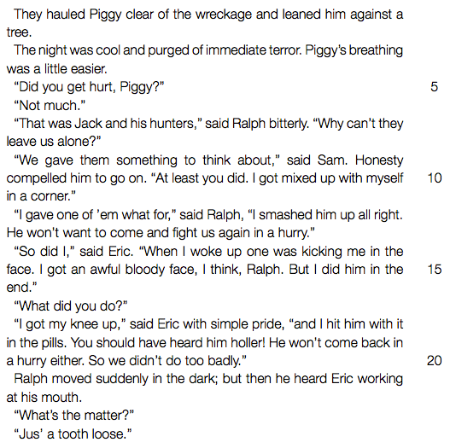

- What is the “wreckage” referred to in line 1?

- In line 3 it is mentioned that Piggy’s breathing is “easier”. Give TWO possible reasons why Piggy was breathing with difficulty earlier.

- Is the following statement TRUE or FALSE? Write “true” or “false” and give a reason for your answer. The person that Ralph is referring to in lines 12-13 is one of the attackers.

- Give TWO reasons why the boys have separated into two groups at this stage.

- Explain why Jack’s tribe does not take the conch.

