Name:
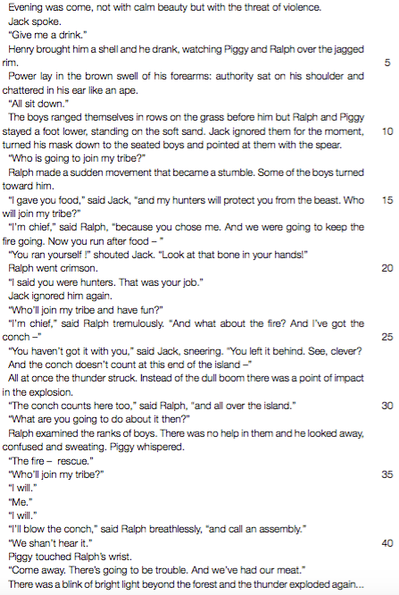
Date:

1. Refer to line 1. To what does the “threat of violence” refer?
2. Refer to lines 2-3. Jack does not ask for a drink but gives an order.
What does this tell us about the kind of leader he is? Give a reason
for your answer.
3. Why does Ralph turn crimson (red) when Jack reminds Ralph that he is eating the food he, Jack, has provided?
4. This extract shows the conflict between Jack and Ralph and their two
different methods of leadership. Explain how the conflict between the two boys can be described as a conflict between democracy and dictatorship.
5. Do you think that Piggy’s advice to “Come away” (line 40) is good advice? Give a reason for your opinion.
6. Why do Ralph and Piggy join the “kill the pig” dance?
7. Briefly relate the events that lead to Simon’s death.

