Name:
Date:
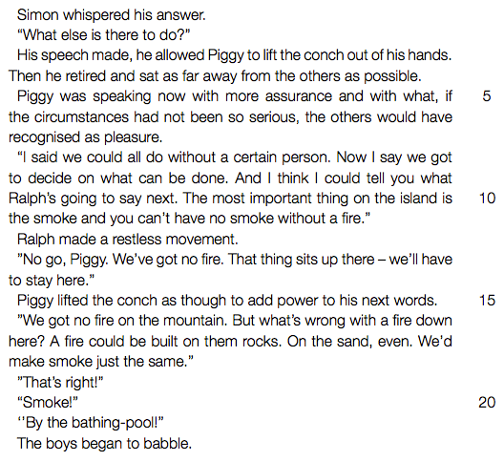

1. Refer to lines 3-11 (“His speech made ... without a fire”).
Identify and discuss the theme of the novel revealed in these lines.
2. Refer to line 8 (“I said we ... a certain person”).
Explain how Piggy’s behavior has changed now that this “certain person” is absent.
3. In your view, who is the better leader, Jack or Ralph? Defend your answer.
4. Chapter 8 is entitled “Gift for the Darkness”.
. (a) What is this “Gift”?
. (b) Discuss what the offering of this “Gift” tells you about the boys at this stage in the novel.

